ACTIVITY

Lab Worksheet

Hypotheses
Activity 1.

Soil 80% went to the top of the tube Sand remained at 100% Clay 90% went to the top of the tube
Activity 2.

Activity 3.
Between the two samples A and B, A is more basic and B was more acidic.
Activity 4.

Sand will have the least porosity because it is smoother in texture.
The soil will have the highest because it’s gritty in texture.
Clay is in between because it’s both gritty and smooth.

Observations/Data Tables
Data Table 1. Particle Size Distribution and Soil Type

 | Depth of Clay Layer (cm) | Depth of Silt Layer (cm) | Depth of Sand Layer (cm) | Total Depth (cm) | %  Clay | %  Silt | %  Sand | Soil Texture
Soil Sample A | 0.1375 | 0.165 | 0 | 5.5 | 2.5% | 3% | 0%

Data Table 2. Determination of Soil Porosity

 | Time Taken for the First Drop to Emerge from Column (s)
Sand Sample | 9 seconds
Clay Sample | 6 seconds
Soil Sample A | 6 seconds

Continued on next page

Data Table 3. PH Comparison of Soil Samples

 | Soil Sample A | Soil Sample B  (Location Description: Very low, acidic )
pH | 7.0 natural | PH 6.0 Neutral

Data Table 4. Nitrogen, Phosphorus, and Potash Comparison in Soil Samples

 | Nitrogen | Phosphorus | Potash
Soil Sample A
Soil Sample B

Photographs
Activity 1. Activity 2.
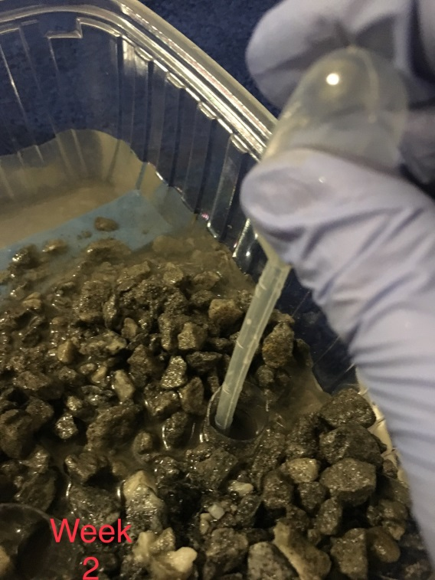
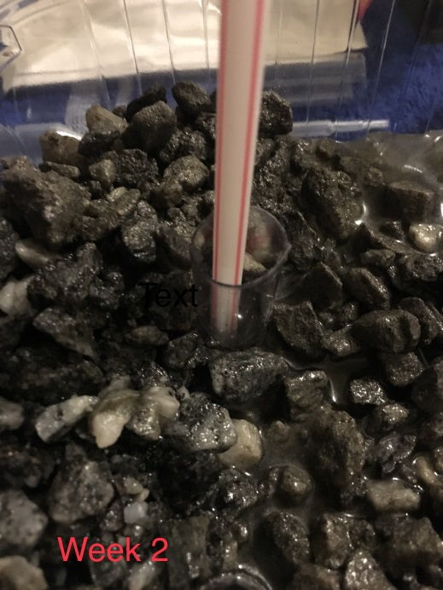

Activity 3. Activity 4.

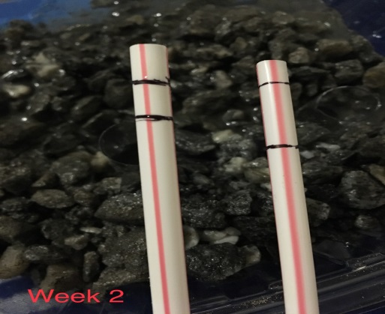
Lab Questions
Please answer the following entirely in your own words and incomplete sentences: Introduction
- Background—what is important to know about the topic of this lab? Use at least one outside source (other than course materials) to answer this question. Cite the source using APA format. Answers should be 5–7 sentences in length.
This topic helps in understanding the different sizes of soil samples and their natural porosity. Knowledge of soil compositions and natural porosity abilities is critical for the analysis of agricultural soils and also for water table analysis purposes. Soil moisture is determined by its porosity and composition, which is important in determining plants which can suit certain soil conditions. Sandy soils and coarse-grained ones have low organic content and moisture content due to large pore spaces hence not advisable for plant growing. Other soil types vary according to the specifications of the compositions the specific plants need.

- Outcomes—What was the main purpose of this lab?
The main purpose of this lab is to learn about soil pores which determine the groundwater for plants and drinking for humans and animals. Soil porosity and components also determine the oxygen content which can be held in between the pores. Proper soil aeration is also important for growing plants and for the survival of underground animals.

- Hypotheses—what were your hypotheses for the activities of this lab? Identify each hypothesis clearly, and explain your reasoning.
- Soil 80% went to the top of the tube Sand remained at 100% Clay 90% went to the top of the tube. This activity is to determine the natural porosity of the soil sample generally, for clay and for sand soil.
- Sand will have the least porosity because it is smoother in texture. The soil will have the highest because it’s gritty in texture. Clay is in between because it’s both gritty and smooth.
- Between the two samples A and, A is more basic and B was more acidic.

Materials and Methods
- Using your own words, briefly describe what materials and methods you used in each of the activities. Your answer should be sufficiently detailed so that someone reading it would be able to replicate what you did. Explain any measurements you made.
[Write your answers here]

Discussion
- Based on the results of each activity, explain whether you accepted or rejected your hypotheses and why.
The results of the soil porosity were as I expected. Sand soil remained at 100% due to its coarse texture which allows water to rise entirely. Clay soil has a smoother texture due to its smoothness hence it went a lower level up the tube than sand.

- What important information have you learned from this lab? Use at least one outside source (scholarly for full credit) to answer this question.
The above information from this lab is essential in that it will enable me to understand different soils and their bulk density, porosity and soil composition. The named soil properties manage the soil ecosystem which determines the productivity capacity of various soils hence one can determine the plants or agricultural practices which can suit certain soil types.
Reference: J. R. Archer and P. Smith, 2006: The relation between bulk density, available water capacity, and air capacity of soils: Article first published online: 28 JUL 2006 DOI: 10.1111/j.1365-2389.1972.tb01678.x

- What challenges did you encounter when doing this lab? Name at least one.

Different methods gave different results of soil porosity test. The corresponding data would make it difficult to determine the water content capacity of the soil hence needs lengthy calculations to determine the average soil water content from the different methods.

8. What additional information would you need to know, beyond what you did in this lab, too?
Determine whether a farm would be agriculturally productive or not? Provide at least 3 examples.

- The location and proximity of the farm to agricultural raw material supplies, markets, labour and customers.
- The orientation of the land in terms of direction and quantity of sun and topography of the farm.
- Microclimate status of the farm; air drainage, exposed high spots and temperature variations.
- The existing vegetation covers including any existing vigorous weeds.
Literature Cited
9. List the references you used to answer these questions. (Use APA format, and alphabetize by the last name.)
Carmon, N., & Ben-Dor, E. (2017). An advanced analytical approach for spectral-based modelling of soil properties. Int. J. Emerg. Technol. Adv. Eng, 7, 90-97.
Bastianelli, C., Ali, A. A., Beguin, J., Bergeron, Y., Grondin, P., Hély, C., & Paré, D. (2017). Boreal coniferous forest density leads to significant variations in soil physical and geochemical properties. Biogeosciences, 14(14), 3445-3459

Now copy and paste your answers into the Lab Report provided. Include the data tables and photographs. You may wish to make minor edits to enhance the flow of your resulting lab report.

